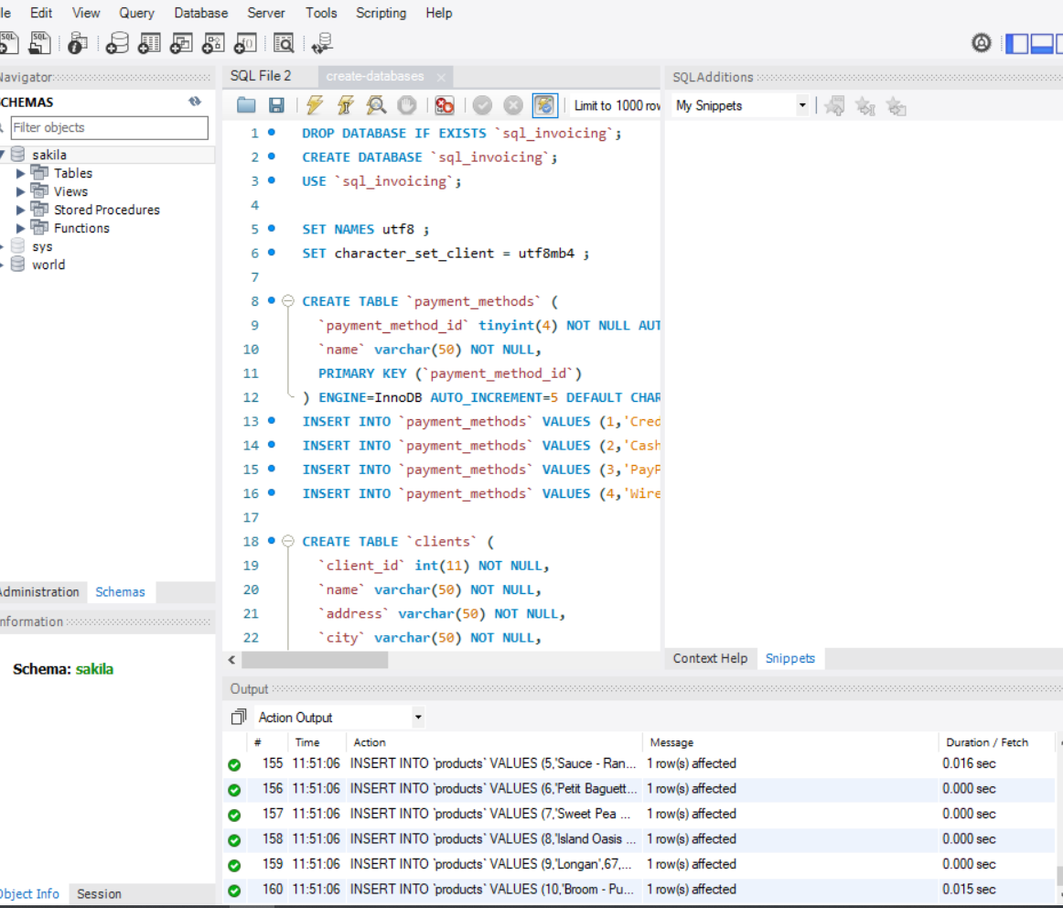

Task 1

Input the following into the Query 1

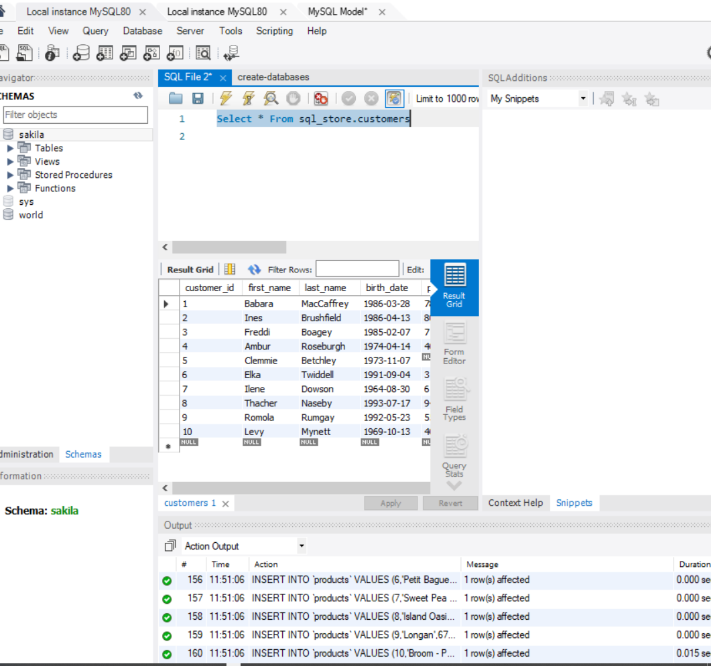

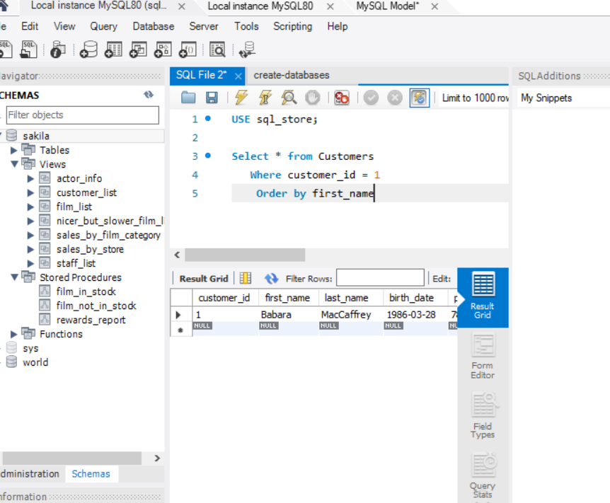

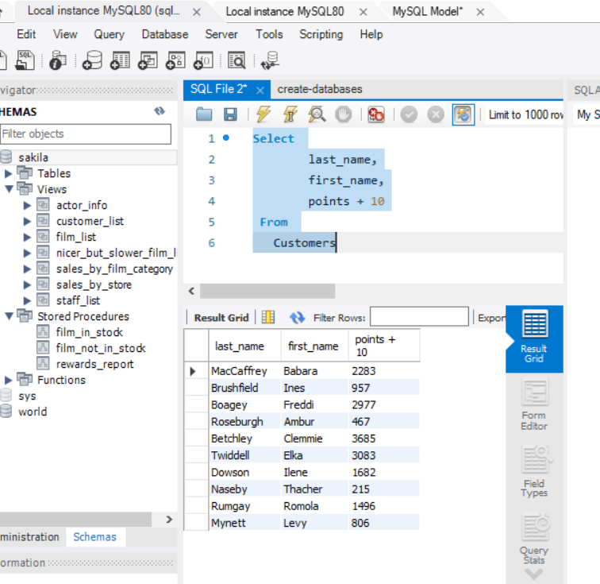

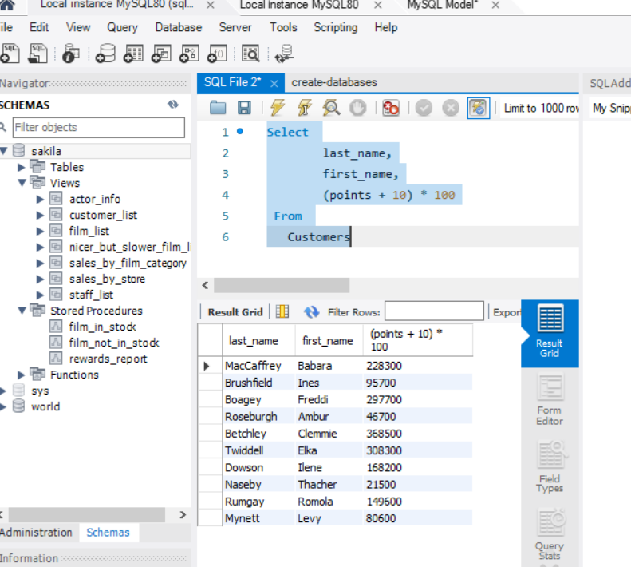

Task 2
- Write a SQL query to return all the products in our database in the result set. I want to make three new columns, name, unit price, and new column called new price, which is based on this expression, (unit price * 1.1).
So, what you are doing is increasing the product price of each by 10%.
So, with the query we want all the products the original price and the new price.

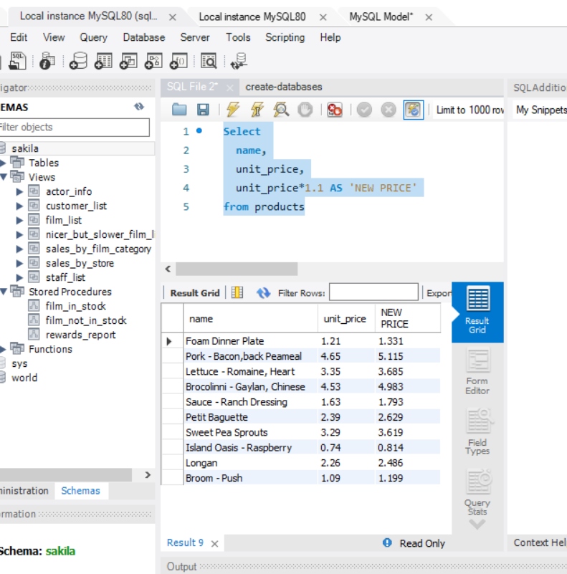

Task 3
- In this task create a new query to find all the customers with a birth date of > '1990-01-01'

